LAB 1 SUBMISSION
name: Abhinav Singh Bhagtana
section: CSE-A
roll no: A-029

Q1.Write a simple poem and represent it as a web page. Give a title for the poem.
Make rhyming words in the poem as bold.

<!DOCTYPE html>
<html lang="en">
<head>
<title>
lab q1
</title>
</head>
<body>
<h1>LAB 1 Q1</h1>
<pre>
In lines of tags and braces <b>tight</b>,
We code till late, from morn to <b>night</b>.
HTML frames the page just <b>right</b>,
CSS paints it bold with style and <b>light</b>.

A script awakes with logic <b>clear</b>,
JavaScript brings the page to <b>cheer</b>.
One missing tag, the bug <b>appears</b>,
We debug with hope—and cups of <b>cheer</b>.

Links connect the world we <b>spin</b>,
From local host to domain <b>in</b>.
In the web lab, we learn and <b>strive</b>,
To make our digital dreams <b>alive</b>.
</pre>
<footer>this is footer</footer>
</body>
</html>

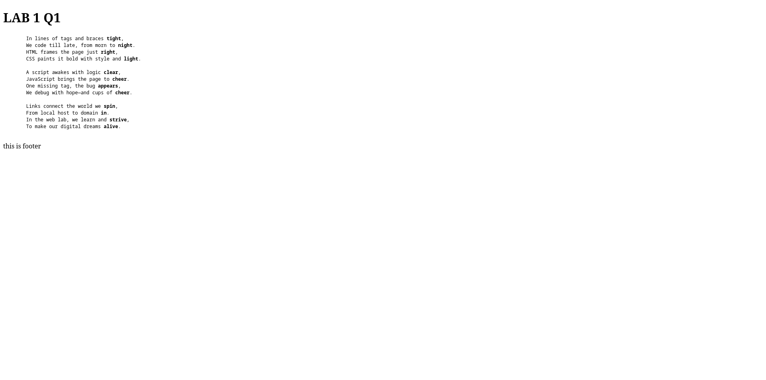

Q2.Assume you have brought a new car. Write down the list of additional accessories you
need for the car as an unordered list in HTML. Also, list the travel plans on the car as an
ordered list.

<!DOCTYPE html>
<html lang="en">
<head>
<title>lab1 q2</title>
</head>
<body>
<h1>LAB1 Q2</h1>
<h2>additional accessories</h2>
<ul>
<li>phone holder</li>
<li>air freshner</li>
<li>cushions</li>
</ul>
<h2>travel plans</h2>
<ol>
<li>Bangalore</li>
<li>Delhi</li>
<li>Kolkata</li>
</ol>
</body>
</html>

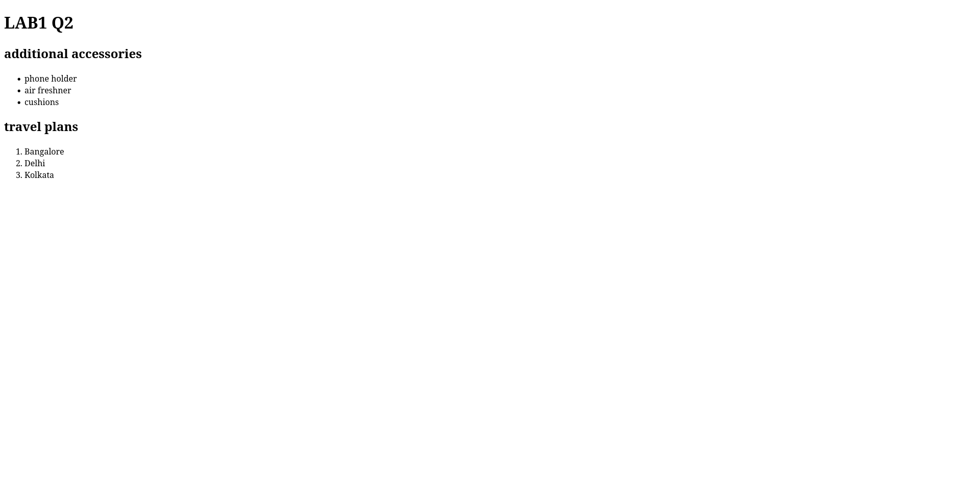
Q3.Complete the following website name “Share your winter vacation videos” the required video files are located inside the compressed folder “Week1 Assignment Files/ Media/”.

<!DOCTYPE html>
<html lang="en">
<head>
<meta charset="UTF-8">
<meta name="viewport" content="width=device-width, initial-scale=1.0">
<title>Lab 1 q3</title>
<link rel="stylesheet" href="q3.css">
</head>
<body>
<h1>Share your Winter Vacation Videos</h1>
<div class="video-container">
<figure>
<video controls>
<source src="video1.mp4" type="video/mp4">
Your browser does not support the video tag.
</video>
<figcaption>Figure 1: video 1</figcaption>
</figure>

<figure>
<video controls>
<source src="video2.mp4" type="video/mp4">
Your browser does not support the video tag.
</video>
<figcaption>Figure 2: video 2</figcaption>
</figure>
</div>

</body>
</html>

css:
.video-container {
display: flex;
gap: 20px;
justify-content: center;
flex-direction: row;
}

figure {
width: 300px;
text-align: center;
}

video {
width: 320px;
height: height;
}

